

**عملية الجمع**

**+**



**عملية الطّرح**

**ــ**



**...........................................................................**

**...........................................................................**

**..........................................................................**

**...........................................................................**

**...........................................................................**

**...........................................................................**

**..........................................................................**

**...........................................................................**

**...........................................................................**

**..........................................................................**

**...........................................................................**

**...........................................................................**

**...........................................................................**

**..........................................................................**

**عشرات**

**وحدات**

**جدول المراتب**



**الحـــلّ**

**العمليات**

**الجواب**

**أكبر من **

**أصغر من**

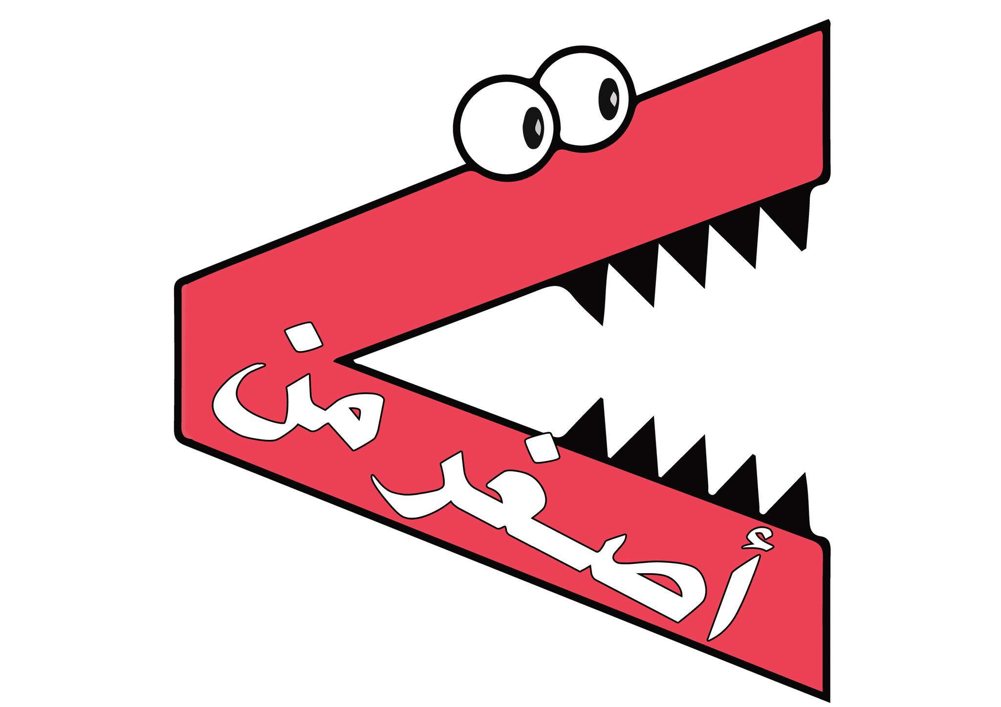

**يساوي**





**مَـــثَلَّثٌ**



**مُــــرَبَّعٌ**



**مُسْتَطِيلٌ**



**دَائِـــرَةٌ**



**أُسْطُوَانَةٌ**



**مُكَعَّبٌ**



**بِلاطَةٌ قَائِمَةٌ**





**كـُــــرَةٌ**



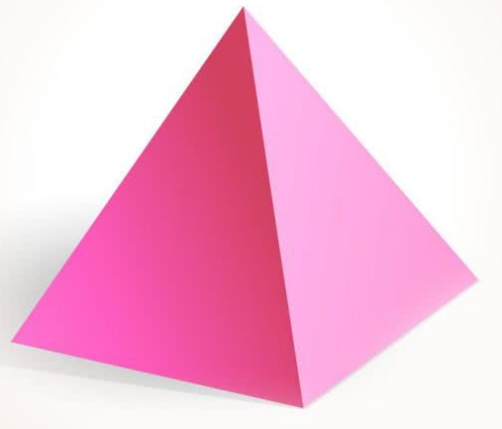

**هَــــرَمٌ**



